WORKSHEET 1 (LIVE SESSION)

RESILIENCE VS CORONAVIRUS (SITUATION)

»Psychological resilience is the ability to mentally or emotionally cope with a crisis or to return to pre-crisis status quickly. Resilience exists when the person uses "mental processes and behaviors in promoting personal assets and protecting self from the potential negative effects of stressors".« (Wikipedia, 2020)
»Developing a view of ourselfs as strong (but sometimes still vulnerable), capable people able to exceed adversity, find hapiness and follow our goals.« (Neenan, 2009)

HOW TO DEVELOP AND NURTURE MY RESILIENCE AS A PERSON AND AS A THERAPIST? IS THERE A DIFFERENCE?

Coronavirus situation – how is it affecting me:

My mental processes and behaviours to protect myself in Coronavirus situation:

Coronavirus situation – how is it affecting my work (being a therapist):

My mental processes and behaviours to protect myself as a therapist in Coronavirus situation:

BEING RESILIENT ALSO MEANS BEING IN TOUCH WITH OURSELFS. IN THIS PICTURE WE CAN SEE FOUR PIECES OF A WHOLE CIRCLE AND WE CAN ALSO SEE DIFFERENT FACTORS WHICH HELPS US TO REMAIN CONNECTED. WHAT ARE YOUR FREE ASSOCIATIONS ACCORDING TO EACH FACTOR?

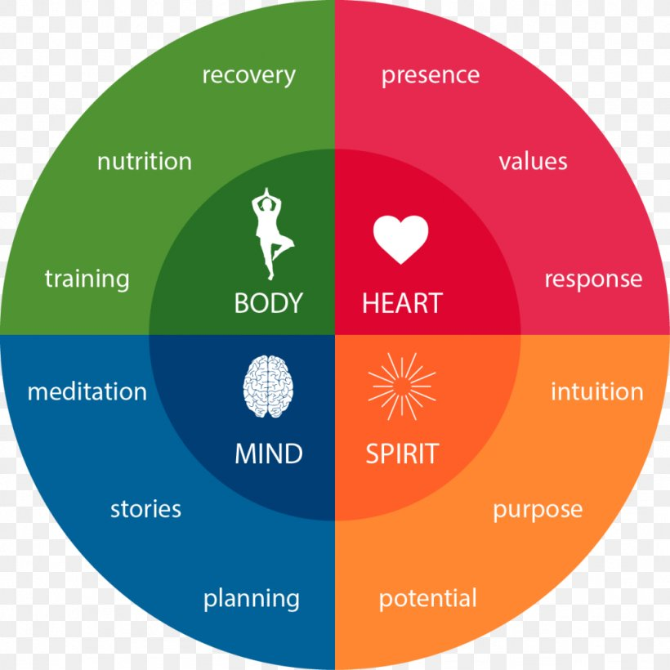
(From: https://favpng.com/png_view/resilience-psychological-resilience-mind-intuition-emotion-png/7ZjFuX2y , 2020)

